Eric Smith; Tyler MacNeil

March 7, 2018

CS385: Progress Report 1

**Team Members:**

Tyler MacNeil: Completed modifications on provided regfile and worked together to merge into the mips-r-type+addi.v file. Worked on Progress report instruction set architecture, drew CPU data path, and ALU1 1-bit.

Eric Smith: Completed modifications on provided ALU file and worked together to merge into the mips-r-type+addi.v file. Worked on progress report instruction set architecture, drew RegFile, and 16-bit ALU.

**Instruction Set Architecture of the Current Version of the CPU:**

In this current version of our CPU, our CPU consists of a 16-bits of binary data. Each section correlates to the opcode, registers and/or immediate value depending on the register type. An Example line of an addi instruction code:



The first 4-bits in the code, 0100, correlate to the opcode which is the addi opcode. The next 2-bits are the rs address, 00. Followed by another 2-bits denoting the rt register address, 01. The last 8-bits correspond to the immediate value which in this case is 15, so 0000 1111.

|  |  |  |  |
| --- | --- | --- | --- |
| Instruction Set/Meaning | | | |
| Instruction | Opcode | Format | Meaning |
| add | 0000 | R-type instruction | Adds register rs and rt and places the result in rd |
| sub | 0001 | R-type instruction | Subtracts rt from rs and places result into rd |
| and | 0010 | R-type instruction | Performs the ‘and’ operation between rt and rs and places result into register rd |
| or | 0011 | R-type instruction | Performs the ‘or’ operation between rt and rs and places the result in register rd |
| slt | 0111 | R-type instruction | If rs is less than rt, place 1 in register rd |
| addi | 0100 | I-type instruction | Adds the immediate value to register rt and places the result in rs |

Instruction format key:

R-format (add, sub, and, or, slt)

|  |  |  |  |  |
| --- | --- | --- | --- | --- |
| op | rs | rt | rd | unused |
| 4 | 2 | 2 | 2 | 6 |

I-format (addi)

|  |  |  |  |
| --- | --- | --- | --- |
| op | rs | rt | address/value |
| 4 | 2 | 2 | 8 |

**Logic Diagram and Truth Tables:**

CPU (Single Cycle data path):

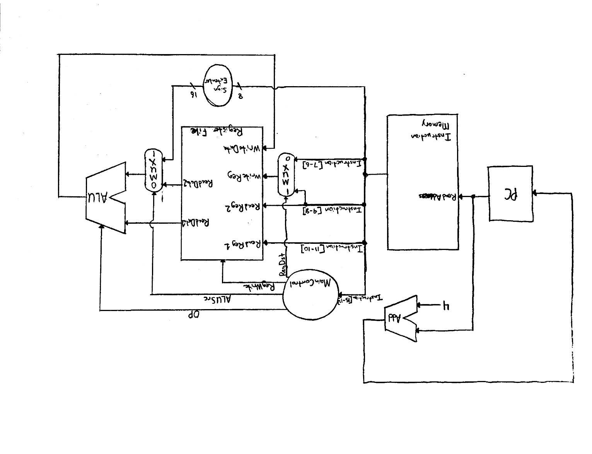

Reg File:

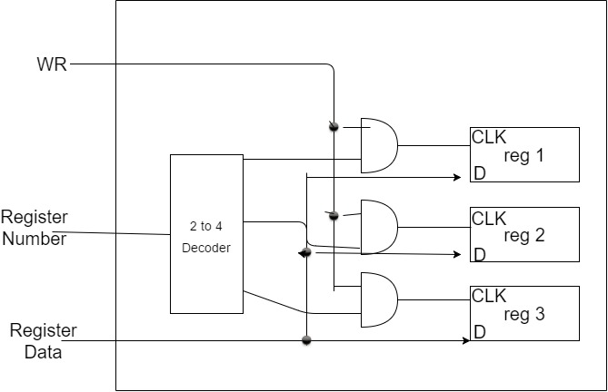

ALU1 1-bit:

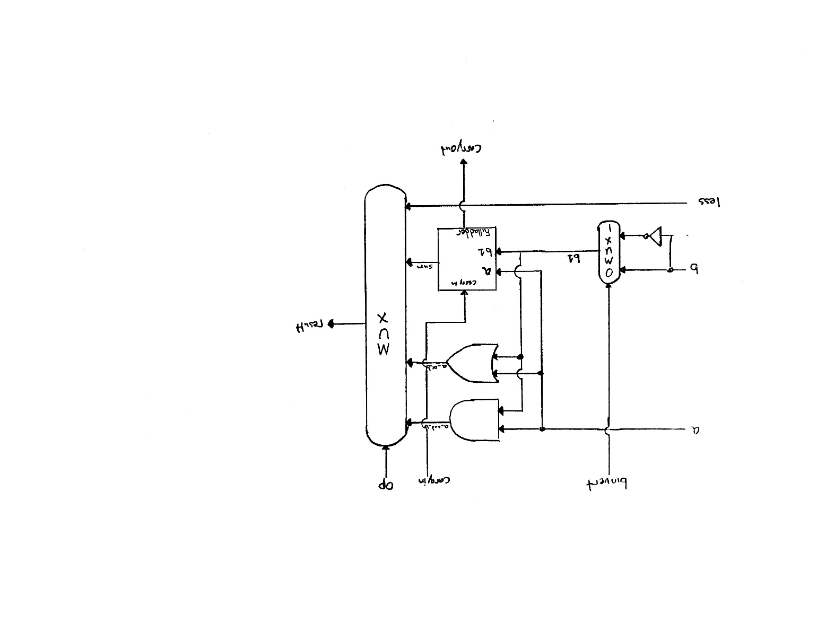

ALU 16-bit:

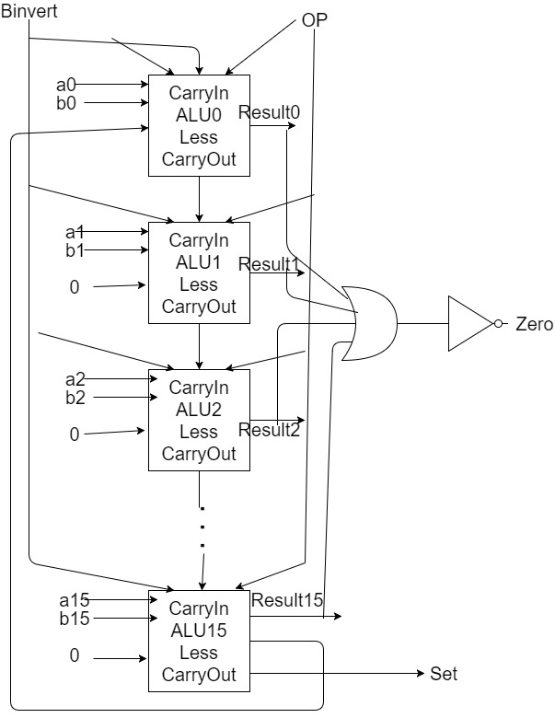

**Source Code:**

|  |
| --- |
| // Structural model of MIPS - single cycle implementation, R-types and addi  // author: Tyler MacNeil, Eric Smith  // data: March 3, 2016  // Iteration: 1  //MIPS register file (4 registers, 16-bit data)  module reg_file (rr1,rr2,wr,wd,regwrite,rd1,rd2,clock);    input [1:0] rr1,rr2,wr;  input [15:0] wd;  input regwrite,clock;  output [15:0] rd1,rd2;  wire [15:0] q1,q2,q3;    // Registers  register reg1(wd,c1,q1);  register reg2(wd,c2,q2);  register reg3(wd,c3,q3);  // Output Port  mux4x1_16bit mux1 (16'b0,q1,q2,q3,rr1,rd1),  mux2 (16'b0,q1,q2,q3,rr2,rd2);  // Input Port  decoder dec(wr[1],wr[0],w3,w2,w1,w0);    and and0 (regwrite_and_clock,regwrite,clock),  and1 (c1,regwrite_and_clock,w1),  and2 (c2,regwrite_and_clock,w2),  and3 (c3,regwrite_and_clock,w3);  endmodule  // Registers build  module register(D,CLK,Q);  input [15:0] D;  input CLK;  output [15:0] Q;    D_flip_flop r1 (D[0],CLK,Q[0]);  D_flip_flop r2 (D[1],CLK,Q[1]);  D_flip_flop r3 (D[2],CLK,Q[2]);  D_flip_flop r4 (D[3],CLK,Q[3]);  D_flip_flop r5 (D[4],CLK,Q[4]);  D_flip_flop r6 (D[5],CLK,Q[5]);  D_flip_flop r7 (D[6],CLK,Q[6]);  D_flip_flop r8 (D[7],CLK,Q[7]);  D_flip_flop r9 (D[8],CLK,Q[8]);  D_flip_flop r10 (D[9],CLK,Q[9]);  D_flip_flop r11 (D[10],CLK,Q[10]);  D_flip_flop r12 (D[11],CLK,Q[11]);  D_flip_flop r13 (D[12],CLK,Q[12]);  D_flip_flop r14 (D[13],CLK,Q[13]);  D_flip_flop r15 (D[14],CLK,Q[14]);  D_flip_flop r16 (D[15],CLK,Q[15]);  endmodule  // MIPS ALU 16-bit in Verilog  module ALU(op,a,b,result,zero);  input [15:0] a,b;  input [2:0] op;  output [15:0] result;  output zero;  wire c1,c2,c3,c4,c5,c6,c7,c8,c9,c10,c11,c12,c13,c14,c15;    ALU1 alu0 (a[0], b[0], op[2],op[1:0],set,op[2],c1, result[0]),  alu1 (a[1], b[1], op[2],op[1:0],0, c1, c2, result[1]),  alu2 (a[2], b[2], op[2],op[1:0],0, c2, c3, result[2]),  alu3 (a[3], b[3], op[2],op[1:0],0, c3, c4, result[3]),  alu4 (a[4], b[4], op[2],op[1:0],0, c4, c5, result[4]),  alu5 (a[5], b[5], op[2],op[1:0],0, c5, c6, result[5]),  alu6 (a[6], b[6], op[2],op[1:0],0, c6, c7, result[6]),  alu7 (a[7], b[7], op[2],op[1:0],0, c7, c8, result[7]),  alu8 (a[8], b[8], op[2],op[1:0],0, c8, c9, result[8]),  alu9 (a[9], b[9], op[2],op[1:0],0, c9, c10,result[9]),  alu10 (a[10],b[10],op[2],op[1:0],0, c10, c11,result[10]),  alu11 (a[11],b[11],op[2],op[1:0],0, c11, c12,result[11]),  alu12 (a[12],b[12],op[2],op[1:0],0, c12, c13,result[12]),  alu13 (a[13],b[13],op[2],op[1:0],0, c13, c14,result[13]),  alu14 (a[14],b[14],op[2],op[1:0],0, c14, c15,result[14]);    ALUmsb alu15 (a[15],b[15],op[2],op[1:0],0, c15, c16,result[15],set);  or or1(or01, result[0],result[1]);  or or2(or23, result[2],result[3]);  nor nor1(zero,or01,or23);  endmodule  module ALU1(a,b,binvert,op,less,carryin,carryout,result);  input a,b,less,carryin,binvert;  input [1:0] op;  output carryout,result;  wire sum,a_and_b,a_or_b,b_inv;    not not1(b_inv, b);  mux2x1 mux1(b,b_inv,binvert,b1);  and and1(a_and_b, a, b);  or or1(a_or_b, a, b);  fulladder adder1(sum,carryout,a,b1,carryin);  mux4x1 mux2(a_and_b,a_or_b,sum,less,op[1:0],result);  endmodule  module ALUmsb(a,b,binvert,op,less,carryin,carryout,result,sum);  input a,b,less,carryin,binvert;  input [1:0] op;  output carryout,result,sum;  wire sum,a_and_b,a_or_b,b_inv;    not not1(b_inv, b);  mux2x1 mux1(b,b_inv,binvert,b1);  and and1(a_and_b, a, b);  or or1(a_or_b, a, b);  fulladder adder1(sum,carryout,a,b1,carryin);  mux4x1 mux2(a_and_b,a_or_b,sum,less,op[1:0],result);  endmodule  // MIPS MainControl  module MainControl(Op,Control);  input [3:0] Op;  output reg [5:0] Control;    always @(Op) case (Op)  4'b0000: Control <= 6'b101010; //add  4'b0001: Control <= 6'b101110; //sub  4'b0010: Control <= 6'b101000; //and  4'b0011: Control <= 6'b101001; //or  4'b0111: Control <= 6'b101111; //slt  4'b0100: Control <= 6'b011010; //addi  endcase  endmodule  // MIPS CPU & Test Program  module CPU(clock,ALUOut,IR);  input clock;  output [15:0] ALUOut, IR;  reg [15:0] PC;  reg [15:0] IMemory[0:1023];  wire [15:0] IR,NextPC,A,B,ALUOut,RD2,SignExtend;  wire [2:0] ALUctl;  wire [2:0] ALUOp;  wire [1:0] WR;  wire RegDst;    // Test Program  initial begin  //R-types are op=2bit rs=2bit rt=2bit rd=2bit unused=6bit  //16'b0100 00 00 00 000000  //I-types are op=4bit rs=2bit rt=2bit address=8bit  //16'b0000 00 00 00000000    IMemory[0] = 16'b0100000100001111; // addi $t1, $0, 15 ($t1=15)  IMemory[1] = 16'b0100001000000111; // addi $t2, $0, 7 ($t2= 7)  IMemory[2] = 16'b0010011011000000; // and $t3, $t1, $t2 ($t3= 7)  IMemory[3] = 16'b0001011110000000; // sub $t2, $t1, $t3 ($t2= 8)  IMemory[4] = 16'b0011101110000000; // or $t2, $t2, $t3 ($t2=15)  IMemory[5] = 16'b0000101111000000; // add $t3, $t2, $t3 ($t3=22)  IMemory[6] = 16'b0111111001000000; // slt $t1, $t3, $t2 ($t1= 1)  IMemory[7] = 16'b0111101101000000; // slt $t1, $t2, $t3 ($t1= 0)    end    initial PC = 0;    assign IR = IMemory [PC>>2];    mux2x1_2bit mux1(IR[9:8],IR[7:6],RegDst,WR);    mux2x1_16bit mux2(RD2,SignExtend,ALUSrc,B); //Sign extended needs 16bit    assign SignExtend = {{8{IR[7]}},IR[7:0]}; // sign extension unit    reg_file rf(IR[11:10],IR[9:8],WR,ALUOut,RegWrite,A,RD2,clock);    ALU fetch (3'b010,PC,4,NextPC,Unused);    ALU ex (ALUctl, A, B, ALUOut, Zero);    MainControl MainCtr (IR[15:12],{RegDst,ALUSrc,RegWrite,ALUctl[2:0]});    always @(negedge clock) begin  PC <= NextPC;  end    endmodule  // Test Module  module test();    reg clock;  wire [15:0] WD, IR;    CPU test_cpu(clock,WD,IR);    always #1 clock = ~clock;    initial begin  $display ("time clock IR WD");  $monitor ("%2d %b %b %d", $time,clock,IR,WD);  clock = 1;  #14 $finish;  end  endmodule  /* Compiling and simulation  >iverilog mips-r-type+addi.vl  >vvp a.out  time clock IR WD  0 1 0100000100001111 15  1 0 0100001000000111 7  2 1 0100001000000111 7  3 0 0010011011000000 7  4 1 0010011011000000 7  5 0 0001011110000000 8  6 1 0001011110000000 8  7 0 0011101110000000 15  8 1 0011101110000000 15  9 0 0000101111000000 22  10 1 0000101111000000 22  11 0 0111111001000000 0  12 1 0111111001000000 0  13 0 0111101101000000 1  14 1 0111101101000000 1  */    // Components  module D_flip_flop(D,CLK,Q);  input D,CLK;  output Q;  wire CLK1,Y;  not not1 (CLK1,CLK);    D_latch D1(D,CLK,Y),  D2(Y,CLK1,Q);    endmodule  module D_latch(D,C,Q);    input D,C;  output Q;  wire x,y,D1,Q1;    nand nand1(x,D,C),  nand2(y,D1,C),  nand3(Q,x,Q1),  nand4(Q1,y,Q);    not not1(D1,D);    endmodule  module mux4x1(i0,i1,i2,i3,select,y);  input i0,i1,i2,i3;  input [1:0] select;  output y;  wire S0,S1,w1,w2,w3,w4;    not not1(S0,select[0]),  not2(S1,select[1]);    and and1(w1,i0,S1,S0),  and2(w2,i1,S1,select[0]),  and3(w3,i2,select[1],S0),  and4(w4,i3,select[1],select[0]);    or or1(y,w1,w2,w3,w4);    endmodule  module mux4x1_16bit(i0,i1,i2,i3,select,y);  input [15:0] i0,i1,i2,i3;  input [1:0] select;  output [15:0] y;    mux4x1 mux1 (16'b0,i1[0], i2[0], i3[0], select[1:0],y[0]),  mux2 (16'b0,i1[1], i2[1], i3[1], select[1:0],y[1]),  mux3 (16'b0,i1[2], i2[2], i3[2], select[1:0],y[2]),  mux4 (16'b0,i1[3], i2[3], i3[3], select[1:0],y[3]),    mux5 (16'b0,i1[4], i2[4], i3[4], select[1:0],y[4]),  mux6 (16'b0,i1[5], i2[5], i3[5], select[1:0],y[5]),  mux7 (16'b0,i1[6], i2[6], i3[6], select[1:0],y[6]),  mux8 (16'b0,i1[7], i2[7], i3[7], select[1:0],y[7]),    mux9 (16'b0,i1[8], i2[8], i3[8], select[1:0],y[8]),  mux10(16'b0,i1[9], i2[9], i3[9], select[1:0],y[9]),  mux11(16'b0,i1[10],i2[10],i3[10],select[1:0],y[10]),  mux12(16'b0,i1[11],i2[11],i3[11],select[1:0],y[11]),    mux13(16'b0,i1[12],i2[12],i3[12],select[1:0],y[12]),  mux14(16'b0,i1[13],i2[13],i3[13],select[1:0],y[13]),  mux15(16'b0,i1[14],i2[14],i3[14],select[1:0],y[14]),  mux16(16'b0,i1[15],i2[15],i3[15],select[1:0],y[15]);    endmodule  module decoder(S1,S0,D3,D2,D1,D0);  input S0,S1;  output D0,D1,D2,D3;    not not1(notS0,S0),  not2(notS1,S1);    and and0(D0,notS1,notS0),  and1(D1,notS1,S0),  and2(D2,S1,notS0),  and3(D3,S1,S0);  endmodule  module halfadder(S,C,x,y);  input x,y;  output S,C;  xor (S,x,y);  and (C,x,y);  endmodule  module fulladder(S,C,x,y,z);  input x,y,z;  output S,C;  wire S1,D1,D2;  halfadder HA1 (S1,D1,x,y),  HA2 (S,D2,S1,z);  or g1(C,D2,D1);  endmodule  module mux2x1(A,B,select,OUT);  input A,B,select;  output OUT;  wire S_inv,wire1,wire2;    not not1(S_inv, select);  and and1(wire1,A,S_inv),  and2(wire2,B,select);  or or1(OUT,wire1,wire2);  endmodule  module mux2x1_2bit(A,B,select,OUT);    input [1:0] A,B;  input select;  output [1:0] OUT;    mux2x1 mux1(A[0],B[0],select,OUT[0]),  mux2(A[1],B[1],select,OUT[1]);    endmodule  module mux2x1_16bit(A,B,select,OUT);  input [15:0] A,B;  input select;  output [15:0] OUT;    mux2x1 mux1 (A[0], B[0], select,OUT[0]),  mux2 (A[1], B[1], select,OUT[1]),  mux3 (A[2], B[2], select,OUT[2]),  mux4 (A[3], B[3], select,OUT[3]),  mux5 (A[4], B[4], select,OUT[4]),  mux6 (A[5], B[5], select,OUT[5]),  mux7 (A[6], B[6], select,OUT[6]),  mux8 (A[7], B[7], select,OUT[7]),  mux9 (A[8], B[8], select,OUT[8]),  mux10(A[9], B[9], select,OUT[9]),  mux11(A[10],B[10],select,OUT[10]),  mux12(A[11],B[11],select,OUT[11]),  mux13(A[12],B[12],select,OUT[12]),  mux14(A[13],B[13],select,OUT[13]),  mux15(A[14],B[14],select,OUT[14]),  mux16(A[15],B[15],select,OUT[15]);  endmodule |

**Test Results:**

